Rescue Diver Notes

Stress causes limiting of focus

Physical and Psychological stressors

Emergency oxygen equipment categories
- Nonresuscitator demand valve units
  - Best option bc highest oxygen concentration for as long as possible
    - Can have multifunction regulators for continuous flow
- Continuous flow units
  - More wasteful bc continuous flow of oxygen
  - Fixed continuous flow units: 6-10 litres per minute
  - Adjustable units deliver up to 25 litres prer minute
  - Recommended flow is 15 litres per minute & with nonrebreather mask & reservoir bag, can deliver 90+% oxygen
    - Bad equipment down to 60% oxygen
- Positive pressure resuscitator units
  - Requires paramedic level training
  - Use pressure from cylinder ot provide rescue breaths
    - Less tiring for rescuer but have high pressure – could overpressure lungs and injure patient
  - With manually triggered resuscitator use those with Emergency Oxygen Provider PADI certification can use

AED
The sooner a shock can be delivered to a heart to restart it (defibrillation) the better odds of the heartbeat returning to normal.
Point of CPR is to extend window before cardiac arrest for shock to be delivered

Accident Management
Victim is diver yet to receive help or not yet in safe & stable state
Patient is diver in emergency that is now in a safe & stable state

Personal readiness & equipment readiness
Personal – fitness and training
Equipment – having right gear, how to use it, where it’s stored, etc

Mentally rehearse emergency scenarios before they happen
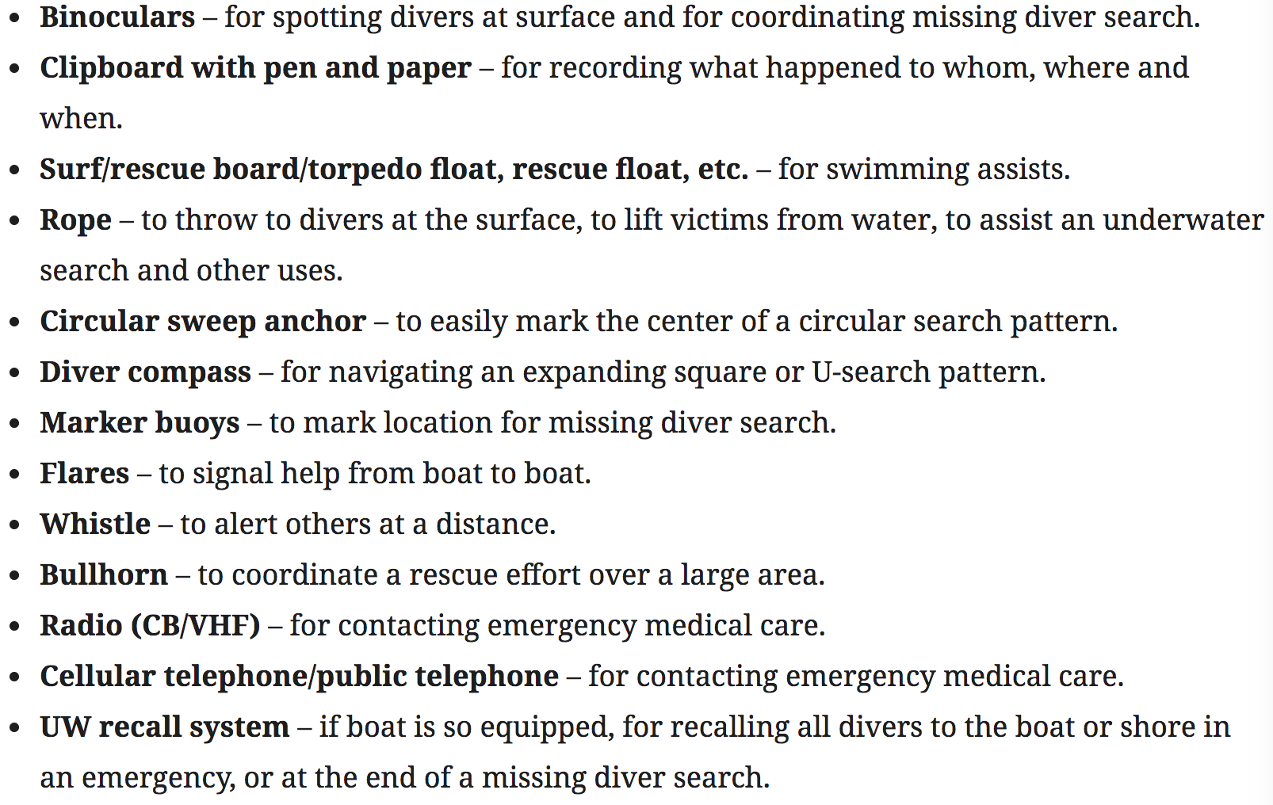

Six steps

- Assess situation
  - Stop. Breathe. Think. Act.
- Act on your plan
  - Calm considered response
- Delegate
  - Quickly, clearly, concisely
  - Call first response & help victim
- Attend to injuries
  - If decompression or lung overexpansion, keep victim laying down
- Control the scene
  - Avoid drawing conclusions or assigning blame
- Arrange evacuation to medical care
  - Helicopter rescue notes
    - Boat face into wind at slight angle
    - Secure everything loose on board and lower all tall objects
    - Don’t touch the line dangling, static shock could kill you

Responding to Diver Emergencies 1
Look after yourself first
Physical preparation
Mental preparation
Equipment preparation
Prevention
Performance
Good buoyancy control
Proper airway control
Cramp removal
Handling air depletion
Responding to vertigo
Make contact with a fixed object

Recognize rescue situations – responsive divers at surface
Stress signs and behaviors:
- Giving distress signals – raising one arm, whistling, yelling for help
- Struggling on or just below the surface
- High treading or finning
- Rejecting equipment
- Clinging and clambering
- Not moving – unresponsiveness

Tired divers
- Adequately managing stress
- Asking for help & responding to questions or directions
- Fatigue, cramp
- Recover quickly

Panicked divers
- Overwhelmed by stress and fear
- Irrational
- Non buoyant, swim vigorously
- More of a threat – migh overpower you

Nonswimming Assists and rescues
How can you provide assistance without entering the water
If you become a victim as well, you divide resoures between saving 2 people
Try to assist from boat, shore, shallow water, deck, pier
- Reaching, extensions, throwing assists
Boat or watercraft next
- Approach from downwind so boat doesn’t blow over victim

Assisting the Responsive diver at the surface
Tired – assist
Panicked - rescue
Steps:
- Approach
  - Quick without gassing yourself
- Evaluate
  - Rational or panicked
  - Drop weights & inflate BCD
- Make contact
  - Establish ample positive buoyancy
- Reassure the tired diver
  - Show you have situation in control
- Assists and transport
  - Keep face above surface
- Equipment removal

Panicked Diver rescue
- Approach and evaluation
  - Exact same
  - Keep eyes on victim the whole time
- Make contact
  - Flotation aid simplifies a surface approach
  - Inflate your BCD
  - Underarm lift – if you’re larger or similar size
  - Knee cradle position – from behind, victim can’t reach you
  - Underwater approach
    - Go underwater to avoid victim if they make contact with you
- Reassure and Transport
  - Vitim normally calms and regains rational thinking
  - Reassure and transport them

